**DAILY ONLINE ACTIVITIES SUMMARY**

|  |  |  |  |  |  |  |
| --- | --- | --- | --- | --- | --- | --- |
| **Date:** | **22-05-2020** | | | **Name:** | **Nachiketh S Bhat** | |
| **Sem & Sec** | **6th - B** | | | **USN:** | **4AL17CS119** | |
| **Online Test Summary** | | | | | | |
| **Subject** | **OR** | | | | | |
| **Max. Marks** | **30** | | **Score** | | **30** | |
| **Certification Course Summary** | | | | | | |
| **Course** | **Machine learning with python** | | | | | |
| **Certificate Provider** | **Cognitiviclass.ai (IBM)** | **Duration** | | | | **10 of 10** |
| **Coding Challenges** | | | | | | |
| **Problem Statemen:**  **1.** C Program to implement various operations of Singly Linked List Stack.  **2**.Java Program to separate the Individual Characters from a String  **3.** Java Program to find the largest and smallest word in a string(a. input with in the program b. input from keyboard). | | | | | | |
| **Status: executed** | | | | | | |
| **Uploaded the report in GitHub** | | **yes** | | | | |
| **If yes Repository name** | | <https://github.com/nachi0106/Daily-Activity/tree/master/Online-coding%20report/22-05-20> | | | | |
| **Uploaded the report in slack** | | **Yes** | | | | |

Online Test Details:

First I A of OR

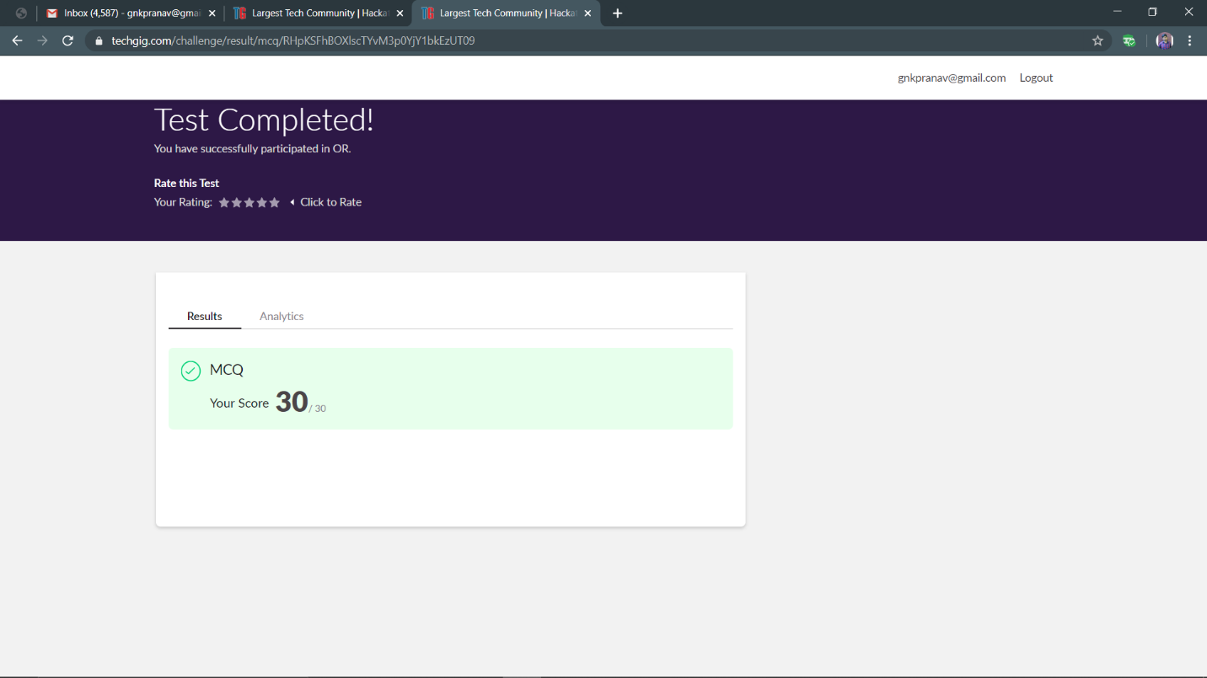

Certification Course Details:

Topic covered

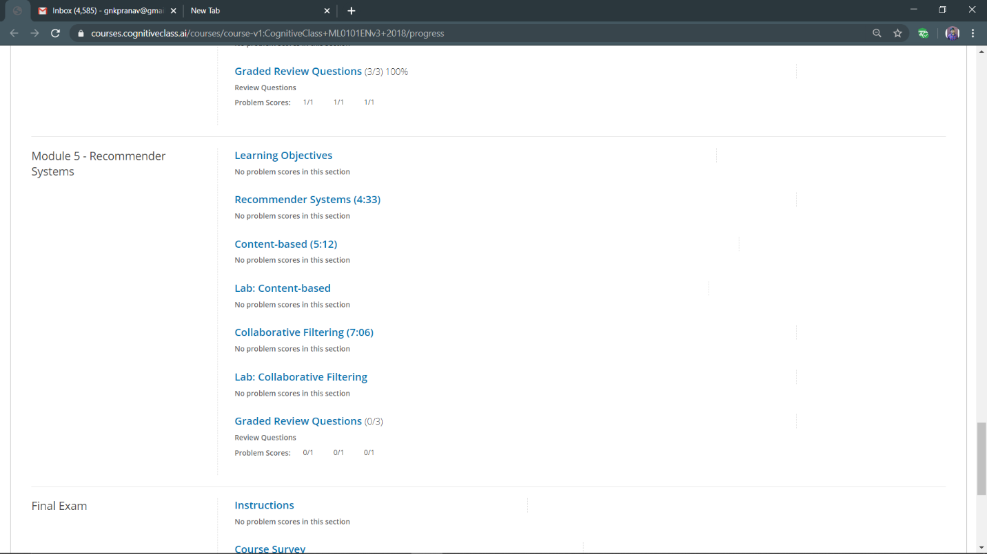

Progress:

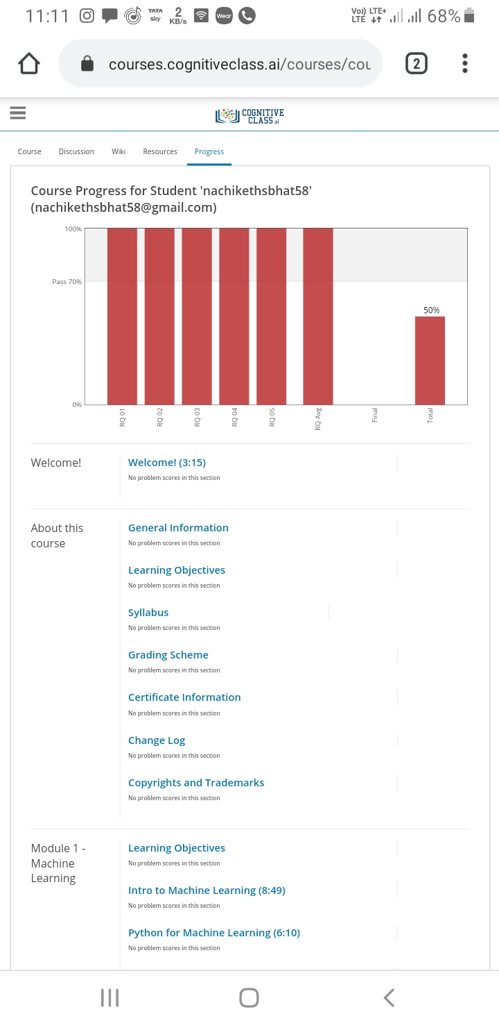

Coding Challenges Details:

The below gitHub link for details

<https://github.com/nachi0106/Daily-Activity/tree/master/Online-coding%20report/22-05-20>

1

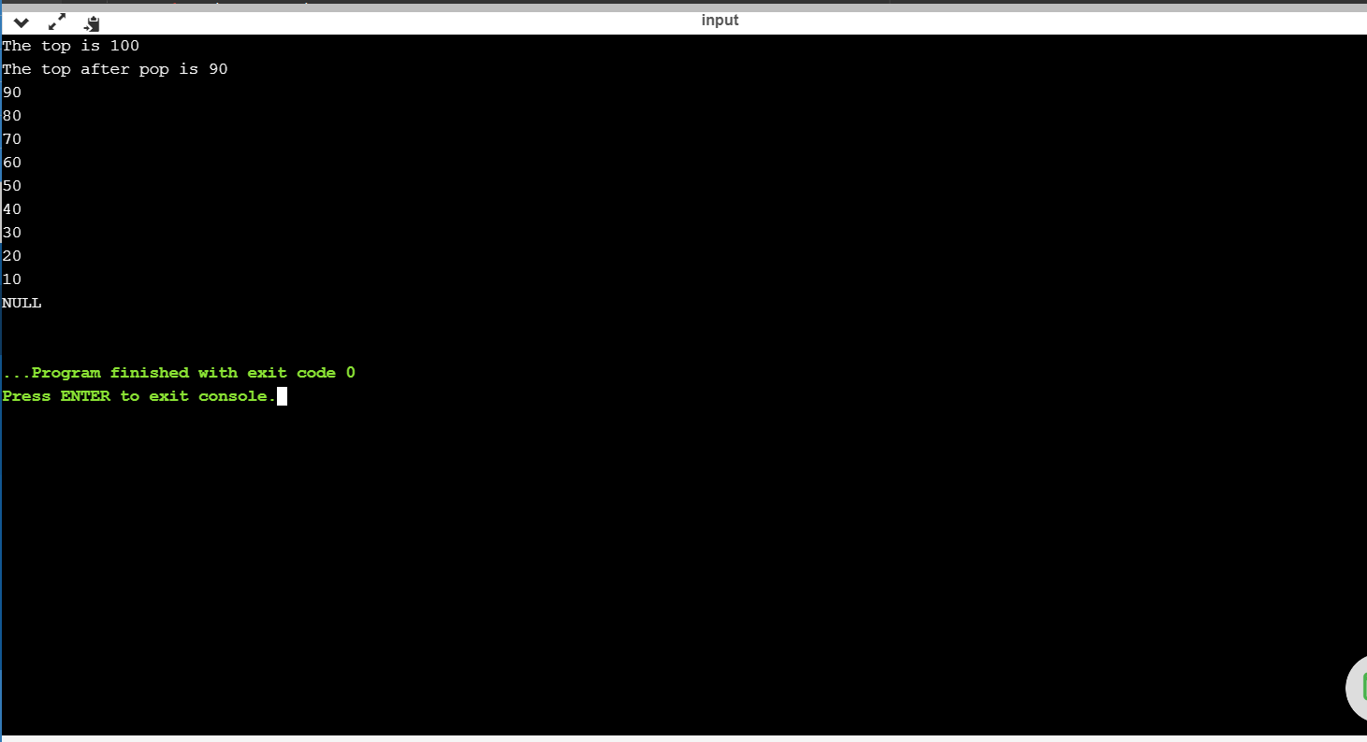

2

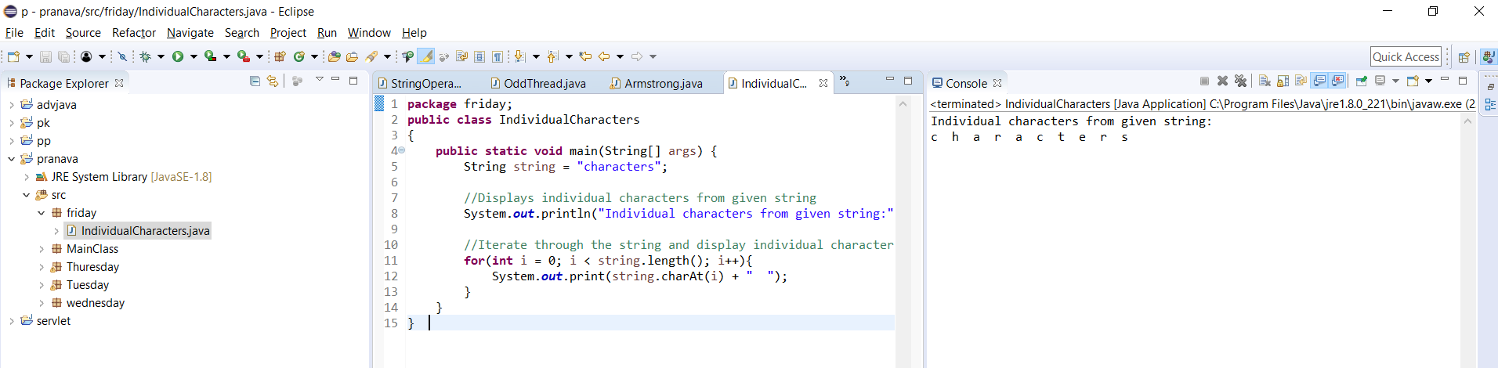

3a (input with in the program)

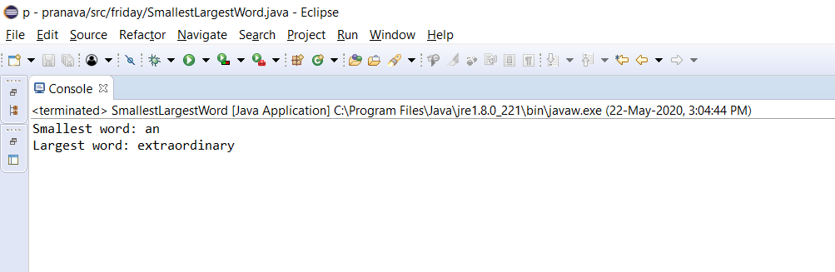

3b (input from the keyboard)

